**Reflective Journal – Azure AI Document Intelligence Lab**

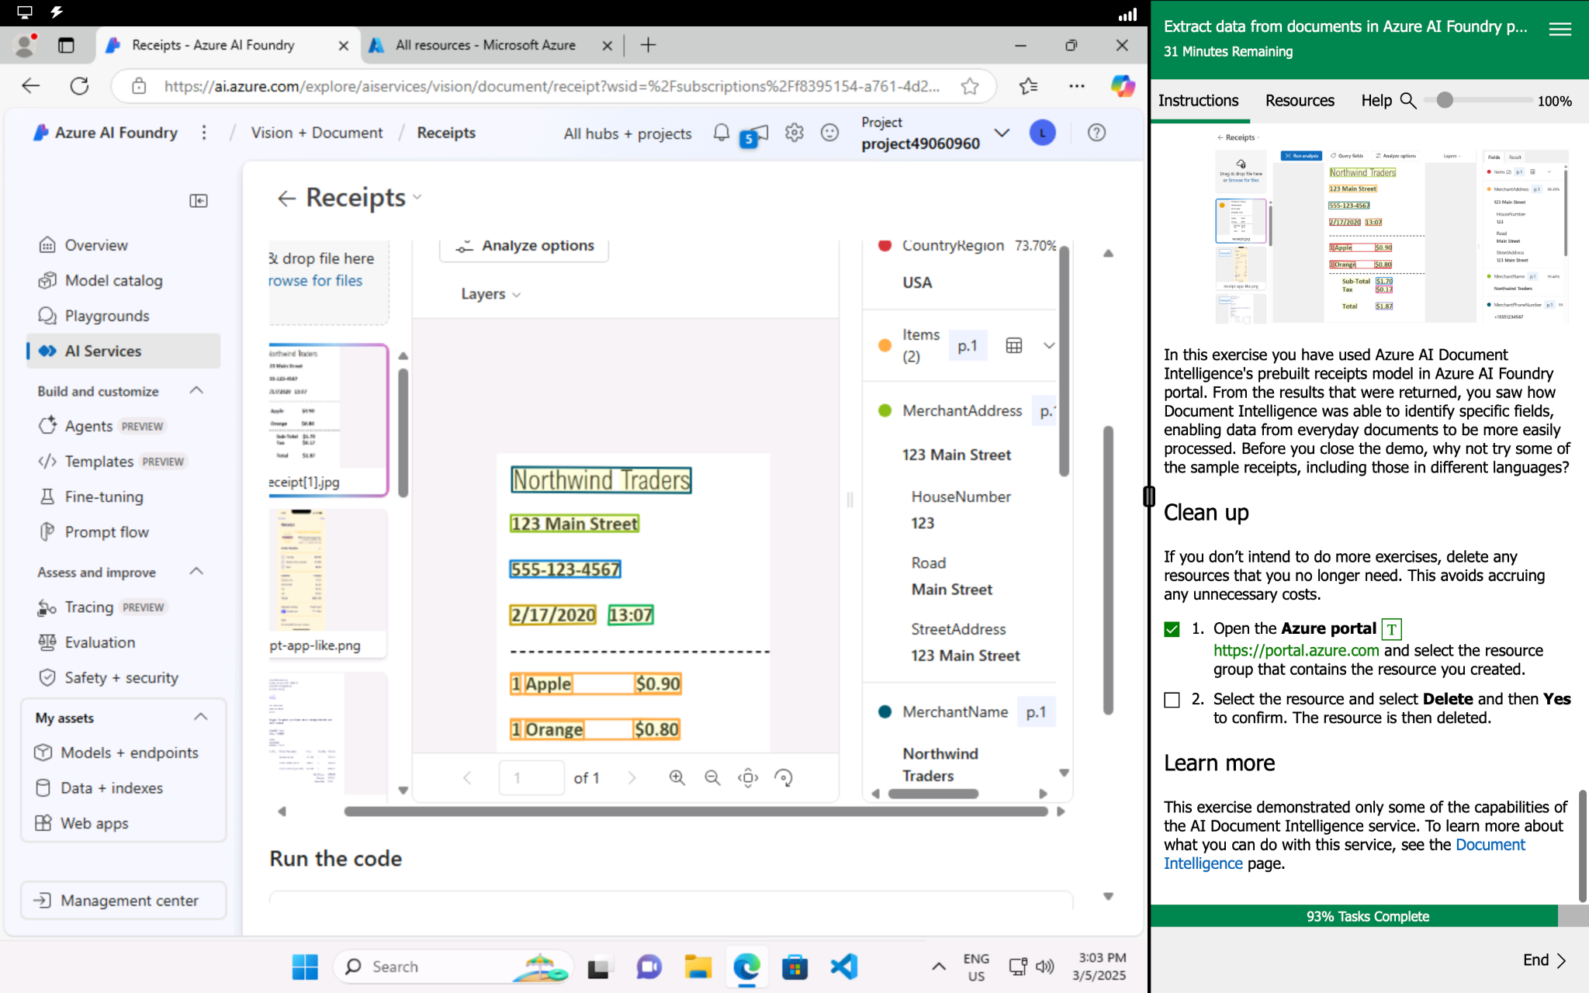

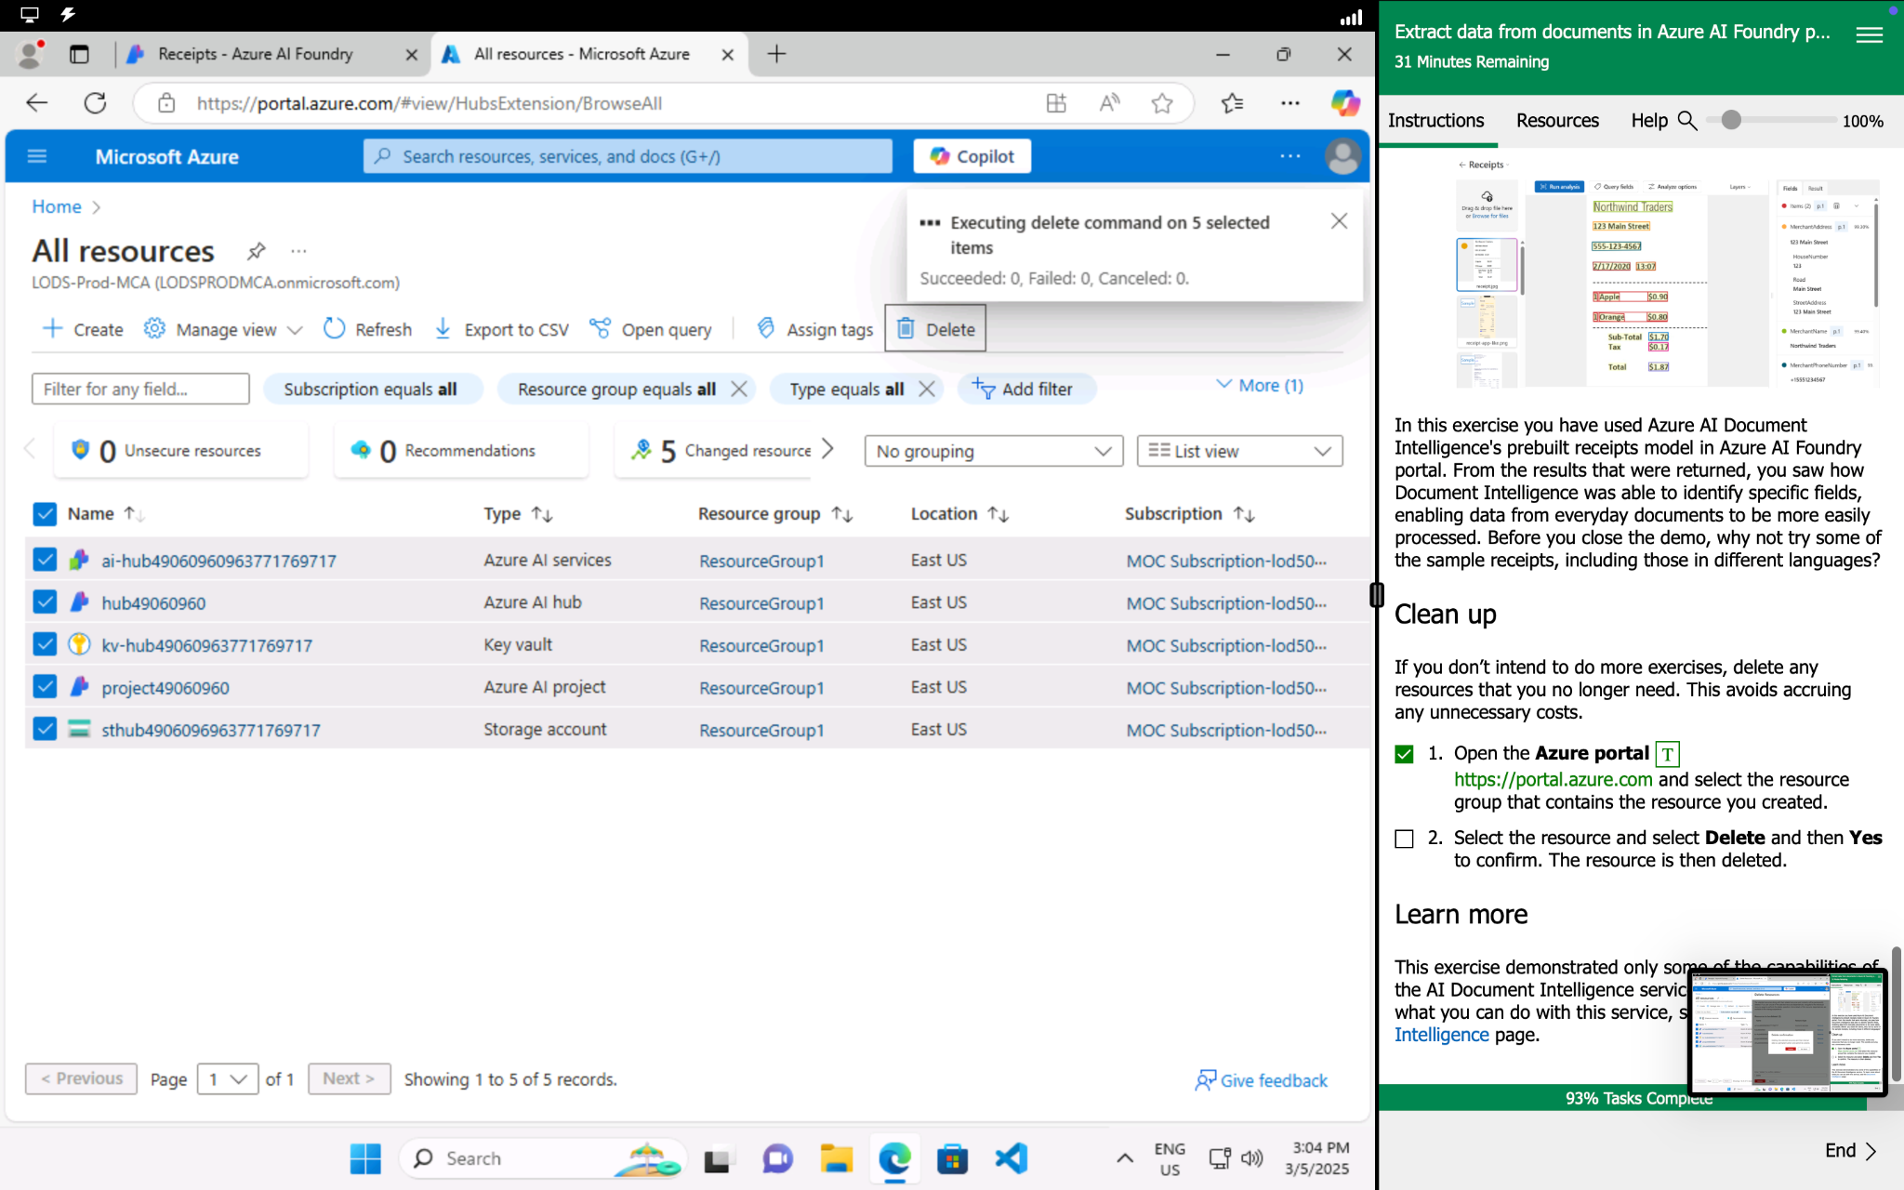

Today’s lab was a straightforward and interesting experience. I worked with Azure AI Document Intelligence's prebuilt receipts model in the Azure AI Foundry portal, which allowed me to analyze receipt data automatically. The model successfully identified key details such as the merchant’s name, address, phone number, transaction date and time, line items, subtotal, tax, and total amounts. Next to each field, the system also provided a probability percentage, showing how confident it was in its accuracy.

One of the things i got most from this lab was seeing how AI can extract structured data from unstructured documents. I now realize how useful this could be for businesses that need to process receipts or invoices in an efficient manner. The ability to analyze documents in different languages also shows how versatile and scalable the tool is.

Unlike some past labs, I faced no difficulty this time. I also noticed that I’m getting better at locating the necessary images for analysis, which was something I previously struggled with. It feels good to see my progress, and this experience has given me more confidence in working with AI-powered tools. I’d say, this was a simple yet insightful exercise that showed me how AI can streamline data extraction from everyday documents.